Nandan
LEC-3: Entity-Relationship Model

ER Model
  - collection of basic objects, called entities and of relationships among these objects.
  - Graphical representation of ER Model is ER diagram, which acts as a blueprint of DB.
  - Entity: An Entity is a “thing” or “object” in the real world that is distinguishable from all other objects.
    - It has physical existence.
    - Each student in a college is an entity.
    - Entity can be uniquely identified. (By a primary attribute, aka Primary Key)
    - Strong Entity: Can be uniquely identified.
    - Weak Entity: Can’t be uniquely identified., depends on some other strong entity.
      - It doesn’t have suﬃcient attributes, to select a uniquely identifiable attribute.
      - Loan -> Strong Entity, Payment -> Weak, as instalments are sequential number counter can be generated separate for each loan.

Weak entity depends on strong entity for existence.

Attributes
        - An entity is represented by a set of attributes.
        - Each entity has a value for each of its attributes.
        - For each attribute, there is a set of permiUed values, called the domain, or value set, of that attribute.
        - E.g., Student Entity has following attributes
          - Student_ID
          - Name
          - Standard
          - Course
          - Batch
          - Contact number
          - Address

Types of Attributes
- Simple
  - Attributes which can’t be divided further.
  - E.g., Customer’s account number in a bank, Student’s Roll number etc.

Composite
  - Can be divided into subparts (that is, other attributes).
  - E.g., Name of a person, can be divided into first-name, middle-name, last-name.
  - If user wants to refer to an entire attribute or to only a component of the attribute.
  - Address can also be divided, street, city, state, PIN code.

Single-valued
  - Only one value attribute.
  - e.g., Student ID, loan-number for a loan.

Multi-valued
  - Attribute having more than one value.
  - e.g., phone-number, nominee-name on some insurance, dependent-name etc.
  - Limit constraint may be applied, upper or lower limits.

Derived
  - Value of this type of attribute can be derived from the value of other related attributes.

Nandan

  - e.g., Age, loan-age, membership-period etc.

NULL Value
- An attribute takes a null value when an entity does not have a value for it.
- It may indicate “not applicable”, value doesn’t exist. e.g., person having no middle-name
- It may indicate “unknown”.
  - Unknown can indicate missing entry, e.g., name value of a customer is NULL, means it is missing as name must have some value.
  - Not known, salary attribute value of an employee is null, means it is not known yet.

Relationships
        - Association among two or more entities.
        - e.g., Person has vehicle, Parent has Child, Customer borrow loan etc.
        - Strong Relationship, between two independent entities.
        - Weak Relationship, between weak entity and its owner/strong entity.
1. e.g., Loan <instalment-payments> Payment.

Degree of Relationship
- Number of entities participating in a relationship.
- Unary, Only one entity participates. e.g., Employee manages employee.
- Binary, two entities participates. e.g., Student takes Course.
- Ternary relationship, three entities participates. E.g, Employee works-on branch, employee works-on job.
- Binary are common.

Relationships Constraints
        - Mapping Cardinality / Cardinality Ratio
- Number of entities to which another entity can be associated via a relationship.
- One to one, Entity in A associates with at most one entity in B, where A G B are entity sets. And an entity of B is associated with at most one entity of A.
  - E.g., Citizen has Aadhar Card.
- One to many, Entity in A associated with N entity in B. While entity in B is associated with at most one entity in A.
  - e.g., Citizen has Vehicle.
- Many to one, Entity in A associated with at most one entity in B. While entity in B can be associated with N entity in A.
  - e.g., Course taken by Professor.
- Many to many, Entity in A associated with N entity in B. While entity in B also associated with N entity in A.
  - Customer buys product.
  - Student aUend course.

Participation Constraints
- Aka, Minimum cardinality constraint.
- Types, Partial G Total Participation.
- Partial Participation, not all entities are involved in the relationship instance.
- Total Participation, each entity must be involved in at least one relationship instance.
- e.g., Customer borrow loan, loan has total participation as it can’t exist without customer entity. And customer has partial participation.
- Weak entity has total participation constraint, but strong may not have total.
      - ER Notations

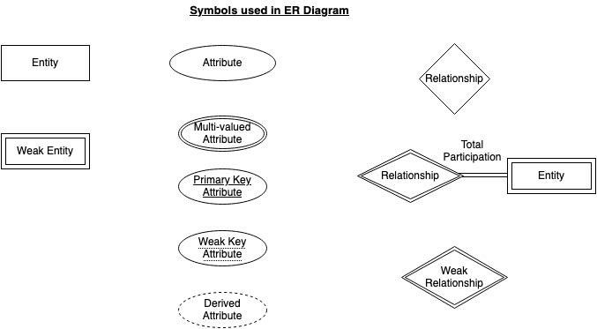
Nandan

